AWS Build process for Compliance Hub

- Login to RDP with your Credentials
  - IP: 10.101.120.179
  - Username: india\empid
  - Password: India domain password

- Login to Putty
  - Hostname: ubuntu@3.228.144.107
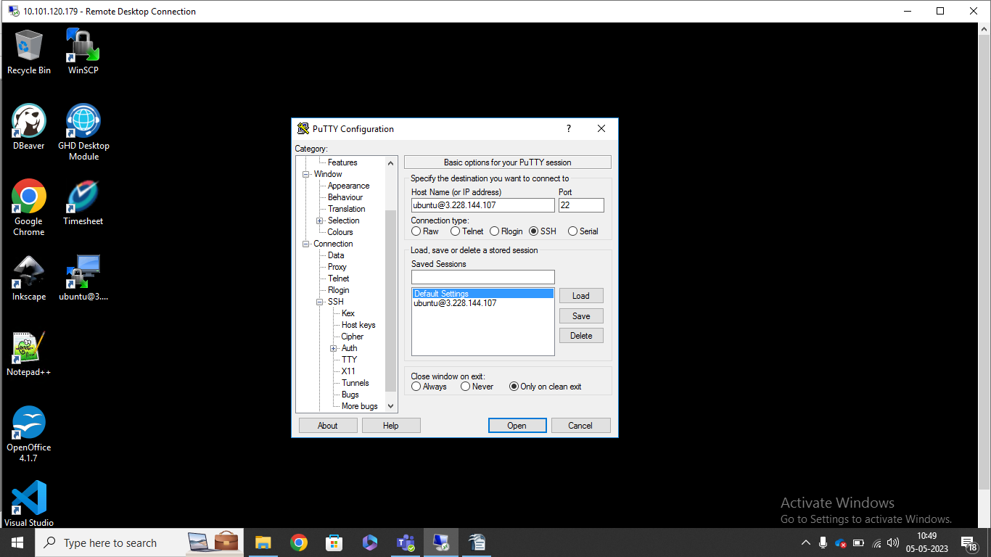
  - Select Private key
    - Expand SSH and click on Auth
    - Browse Private key file (path: E:\Dev-Team\aws) and select VBC_Ubuntu_Demo_Key-private-key.ppk and open

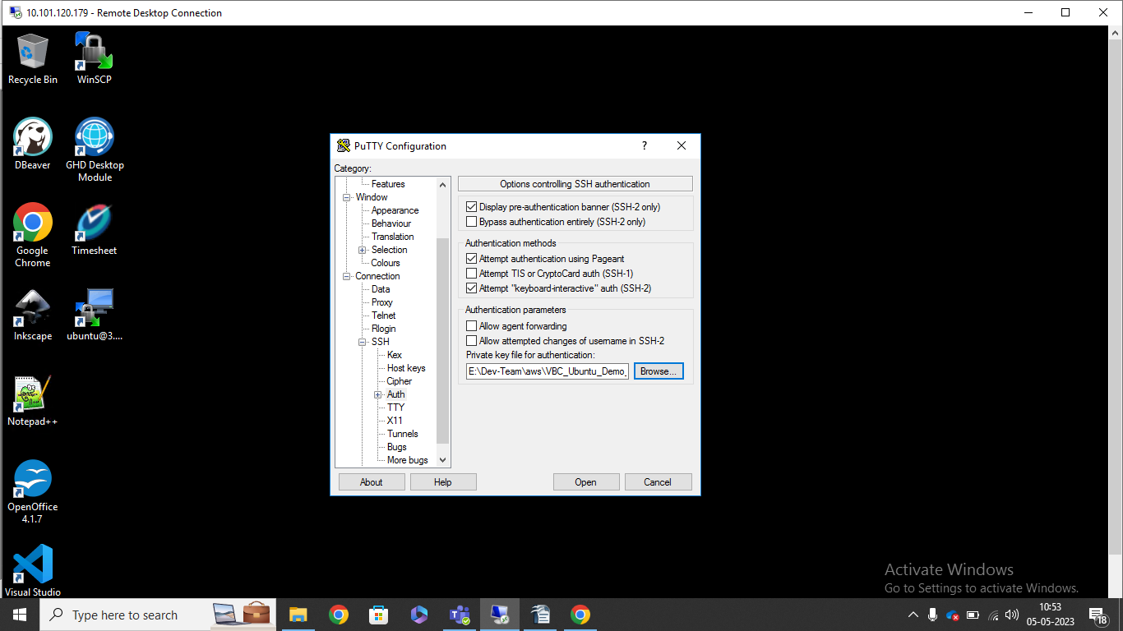
- Login to WinSCP
  - Hostname: 3.228.144.107
  - Username: ubuntu
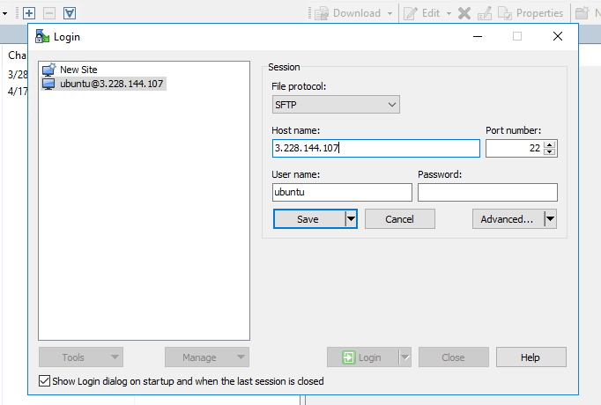
  - Select Private key file
    - Click on Advanced --> SSH --> Authentication
    - Browse Private key file (path: E:\Dev-Team\aws) and select VBC_Ubuntu_Demo_Key-private-key.ppk
    - Save the configuration and Login

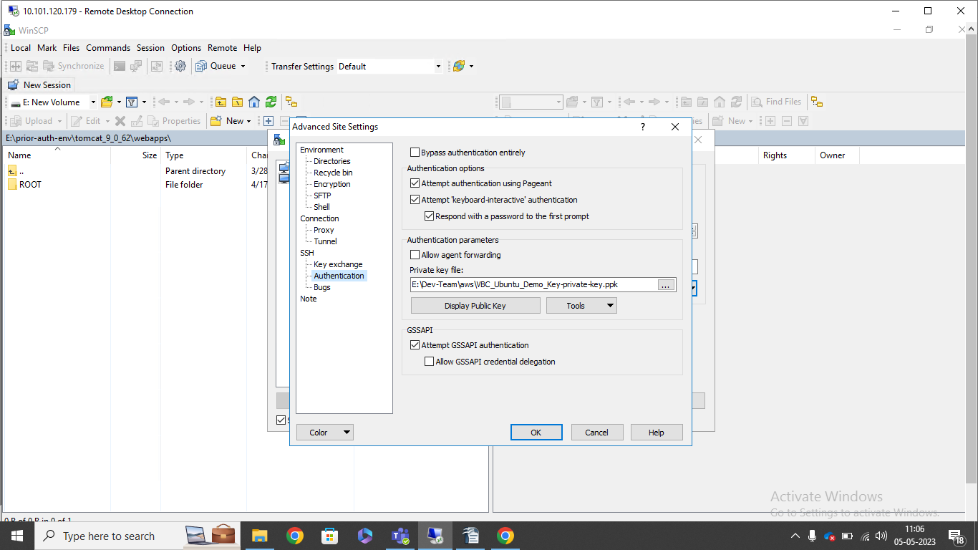

- In WinSCP, go to folder /home/ubuntu/comp_hub/tomcat_9_0_62_public/webapps and copy those files (ROOT, SNAPSHOT and sql) and store in backup folder

- Cleanup the existing data in putty
  - Go to path /home/ubuntu/comp_hub and execute command ./comp_cleanup.sh
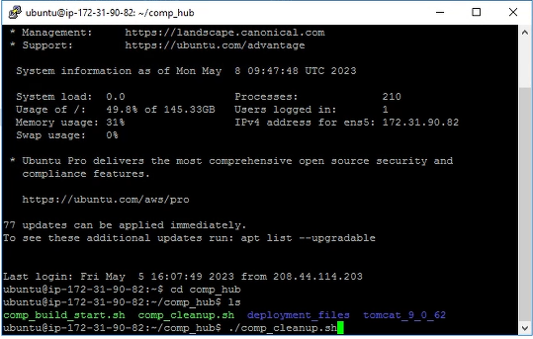
  - Check the files deleted in /home/ubuntu/comp_hub/tomcat_9_0_62_public/webapps

- Copy the files from RDP to Ubuntu
  - Go to path E:/comp-hub-env/tomcat_9_0_62_deploy/webapps in RDP and copy the files
  - Go to path /home/ubuntu/comp_hub/tomcat_9_0_62_public/webapps in Ubuntu and paste

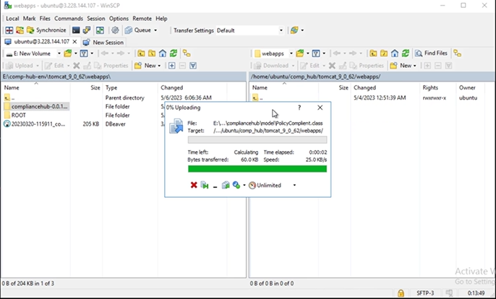

- Drop the VBC schema in putty using below commands
  - Go to path /home/ubuntu/comp_hub
  - Connect to postgres using command sudo su postgres
  - Execute command psql -h localhost 5432 -d comp_hub -U comp_hub_user
  - Give password comp_hub
  - Drop schema using command drop schema comp_hub cascade
  - Execute command \q

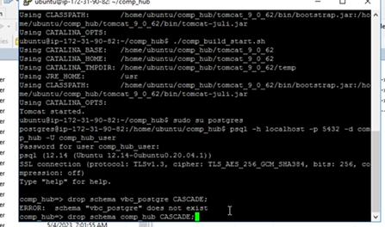

- Load the file 20230427-070750_ comp_hub_schema_data.sql in putty
  - Go to path /home/ubuntu/comp_hub
  - Execute command psql -h localhost 5432 -d comp_hub -U comp_hub_user < /home/ubuntu/comp_hub/tomcat_9_0_62_public/webapps/20230427-070750_comp_hub_schema_data.sql
  - Give password comp_hub

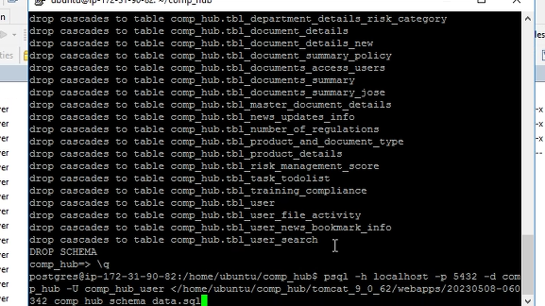

- Duplicate the putty session and start vbc server while above step is in progress
  - Go to path /home/ubuntu/comp_hub
  - Execute command ./comp_build_start.sh

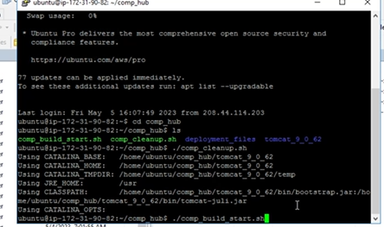
- Check the application is working
  - URL: http://3.228.144.107:8047/

